Multi-Platform Report

Describes the difference between adaptive and responsive design

# Responsive vs Adaptive

Responsive sites and adaptive sites are the same in that they both change appearance based on the browser environment they are being viewed on. (Graham, 2015)

Responsive websites respond to the bowser no matter what the browser width may be, the site adjusts its layout (and perhaps functionality) in a way that is optimised to the screen. (Graham, 2015)

Adaptive websites are only concerned about the browser being a specific width, at which point it adapts the layout. (Graham, 2015)

The simplest way to view this is the difference between smooth and snap design. (Graham, 2015) Responsive design is smooth because the layout fluidly adjusts regardless of what device it is viewed on. (Graham, 2015) Adaptive design, on the other hand, snaps into place because the page is serving something different because of the browser or device it is viewed on. (Graham, 2015)

Here’s an image comparing responsive and adaptive designs from [Medium](https://popart-studio.medium.com/fluid-vs-adaptive-vs-responsive-design-62de51e036bd).

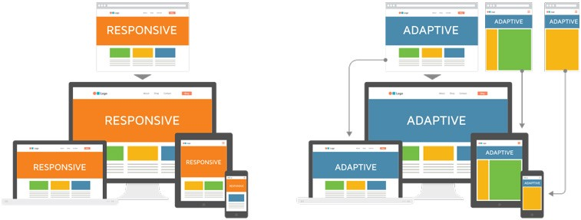

In the example above the responsive picture flows with the environment whereas the adaptive snaps into place at a defined environment. (Graham, 2015)

Responsive design is both fluid and flexible which is a means of becoming device agnostic in the sense that it seeks to create an optimised experience for any screen. (Graham, 2015)

Essentially, we challenge ourselves to create sites that shift context according to how a site is being consumed on any given occasion. (Graham, 2015)

Compare that with an adaptive way of thinking, which is neither fluid nor flexible, but looks for specific points at which to adapt. While it might be difficult to adapt a website on all the various devices being used today. (Graham, 2015)

Both responsive and adaptive designs are similar in the way that they are methods for dealing with the reality that websites are often viewed on different devices in different contexts. They just go about this in different ways. (Graham, 2015)

# Our Decision

Our team’s recommendation is the responsive design, where we have produced a prototype application. As technology is ever changing and moving at a rapid pace, the responsive prototype is delivering a design that is both fluid, flexible and able to adjust its layout and perhaps its functionality in a way that it is optimised to the screen, there for, it can be view on current and future devices. In turn this will future proof the business where it is able grow exponentially